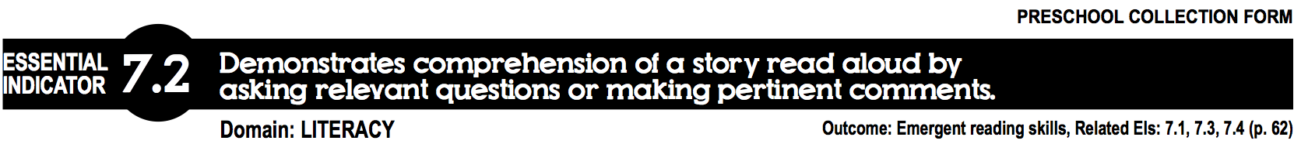

CHILD’S NAME: |  | DATE:
OBSERVER:
Describe what you saw the child do and/or heard the child say:

Family Thoughts:

Check off whatever applies to the context of this observation:
Child-initiated activity | New task for this child | Done independently | Time spent (1-5 mins.)
Teacher-initiated activity | Familiar task for this child | Done with adult guidance | Time spent (5-15 mins.)
 |  | Done with peer(s) | More than 15 mins.
Refer to Early Learning Guidelines  Child’s Progress toward the Outcome:  Check the appropriate rating above. | First Steps for 3s  Relates story content to own experiences (eg., “Look, a dog.) | Making Progress for 3s  Uses own experiences to make comments that may or may not follow along the story line | Accomplished for 3s  First Steps for 4s  Listens to stories for a few minutes and responds by pointing to pictures, turning pages, and/or asking simple questions | Making Progress for 4s  Listens to stories and responds by asking related questions and/or making pertinent comments | Accomplished for 4s  First steps for K  Listens to stories and responds by asking related questions and making predictions or retelling stories read | Exceeds for 4s  Role plays main events of a story with puppets or other props | Refer to Early Learning Guidelines

Check the additional Essential Indicators that are embedded in the documentation:
EI # 6.1 (Conversational Ability) | EI #20.1 (Plays and Interacts) | EI #25.3 (Role Plays)
EI #17.4 (Family, Community, Culture) | EI #20.2 (Social Problem Solving) | EI #27.1 (Focus)
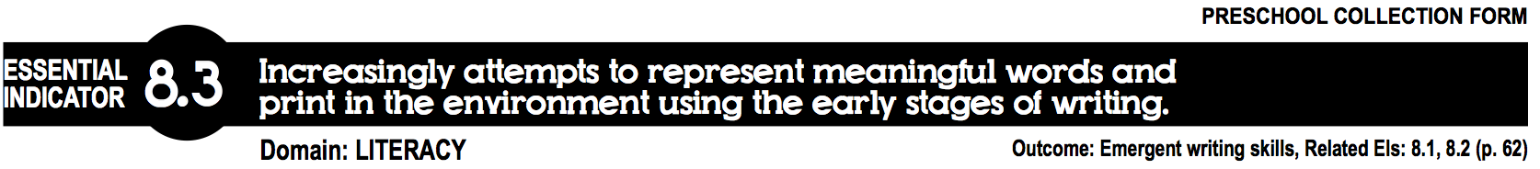

CHILD’S NAME: |  | DATE:
OBSERVER:
Describe what you saw the child do and/or heard the child say:

Family Thoughts:

Check off whatever applies to the context of this observation:
Child-initiated activity | New task for this child | Done independently | Time spent (1-5 mins.)
Teacher-initiated activity | Familiar task for this child | Done with adult guidance | Time spent (5-15 mins.)
 |  | Done with peer(s) | More than 15 mins.
Refer to Early Learning Guidelines  /  Child’s Progress toward the Outcome:  Check the appropriate rating above. | First Steps for 3s  Makes marks or scribbles in addition to drawings | Making Progress for 3s  Makes marks or scribbles in response to adult suggestions for writing | Accomplished for 3s  First Steps for 4s  Makes marks or scribbles and identifies them as writing | Making Progress for 4s  Purposefully makes marks, scribbles or letter-like shapes identifying the writing as words or print in the environment | Accomplished for 4s  First steps for K  Shows increasing control of the writing tool as seen in the formation of letter-like shapes, forms of pretend cursive writing and some letters; may write some words or names | Exceeds for 4s  Writes own first and last name and many additional letters of the alphabet | Refer to Early Learning Guidelines
/
Check the additional Essential Indicators that are embedded in the documentation:
EI # 6.1 (Conversational Ability) | EI #20.1 (Plays and Interacts) | EI #25.3 (Role Plays)
EI #17.4 (Family, Community Culture) | EI #20.2 (Social Problem Solving) | EI #27.1 (Focus)
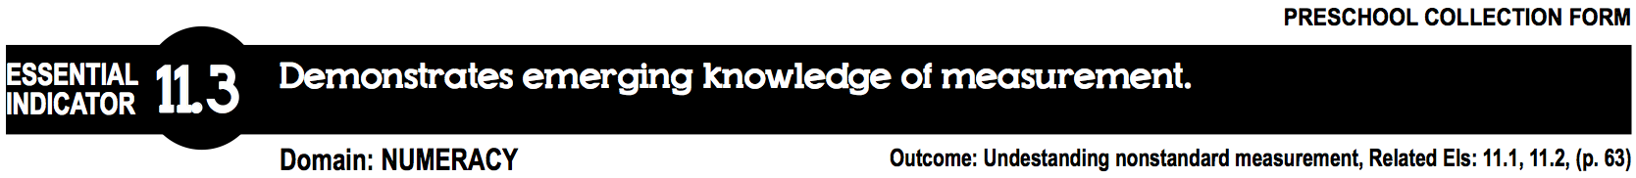

CHILD’S NAME: |  | DATE:
OBSERVER:
Describe what you saw the child do and/or heard the child say:

Family Thoughts:

Check off whatever applies to the context of this observation:
Child-initiated activity | New task for this child | Done independently | Time spent (1-5 mins.)
Teacher-initiated activity | Familiar task for this child | Done with adult guidance | Time spent (5-15 mins.)
 |  | Done with peer(s) | More than 15 mins.
Refer to Early Learning Guidelines  Child’s Progress toward the Outcome:  Check the appropriate rating above. | First Steps for 3s  Identifies objects as big or small | Making Progress for 3s  Identifies objects that are similar in size or length | Accomplished  for 3s  First Steps for 4s  Sorts objects that are similar in size and length | Making Progress for 4s  Sorts objects that are similar and different in size length, weight, or capacity | Accomplished  for 4s  First steps for K  Uses words to describe a measureable property (e.g. size, length, weight, or capacity) | Exceeds for 4s  Uses words to compare two objects on a measureable property (e.g., bigger/smaller, longer or taller/short, heavier/lighter, more full/less full) | Refer to Early Learning Guidelines
/
Check the additional Essential Indicators that are embedded in the documentation:
EI # 6.1 (Conversational Ability) | EI #20.1 (Plays and Interacts) | EI #25.3 (Role Plays)
EI #17.4 (Family, Community Culture) | EI #20.2 (Social Problem Solving) | EI #27.1 (Focus)
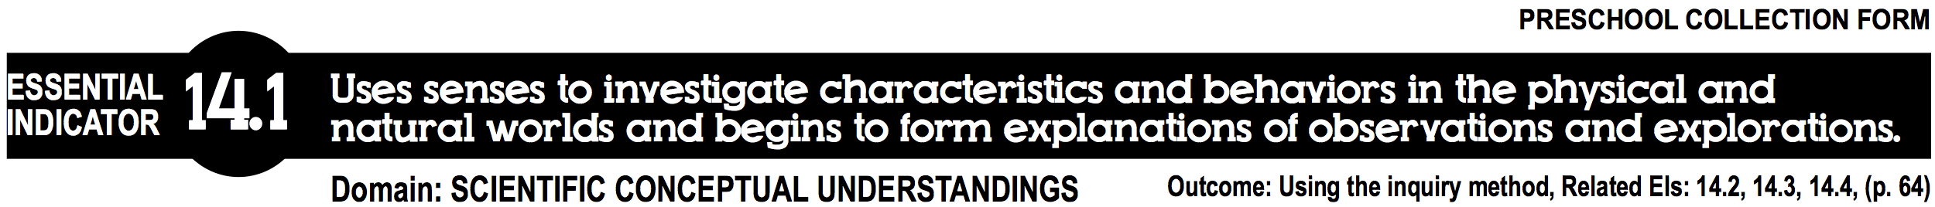

CHILD’S NAME: |  | DATE:
OBSERVER:
Describe what you saw the child do and/or heard the child say:

Family Thoughts:

Check off whatever applies to the context of this observation:
Child-initiated activity | New task for this child | Done independently | Time spent (1-5 mins.)
Teacher-initiated activity | Familiar task for this child | Done with adult guidance | Time spent (5-15 mins.)
 |  | Done with peer(s) | More than 15 mins.
Refer to Early Learning Guidelines  Child’s Progress toward the Outcome:  Check the appropriate rating above. | First Steps for 3s  Plays with materials of different textures (e.g., sand, water, leaves) with adult encouragement | Making Progress for 3s  Plays with materials of different textures (e.g., sand, water, leaves) and conditions (wet, dry, warm, cold, etc.) with adult encouragement | Accomplished for 3s  First Steps for 4s  Uses obvious sensory information to explore the world, reacting more physically than verbally | Making Progress for 4s  Uses one sense (such as sight only or smell only) in a sensory experience, making 1-2 simple comments describing the experience | Accomplished for 4s  First steps for K  Uses 2 or more senses (such as both sight and smell, or hearing and touch) to explore the world and makes 1 or more detailed comments describing sensory experiences | Exceeds for 4s  Conducts small hands-on/multi-sensory experiments with adult guidance and uses observation and verbal questioning and comments to investigate and draw conclusions. | Refer to Early Learning Guidelines

Check the additional Essential Indicators that are embedded in the documentation:
EI # 6.1 (Conversational Ability) | EI #20.1 (Plays and Interacts) | EI #25.3 (Role Plays)
EI #17.4 (Family, Community Culture) | EI #20.2 (Social Problem Solving) | EI #27.1 (Focus)

CHILD’S NAME: |  | DATE:
OBSERVER:
Describe what you saw the child do and/or heard the child say:

Family Thoughts:

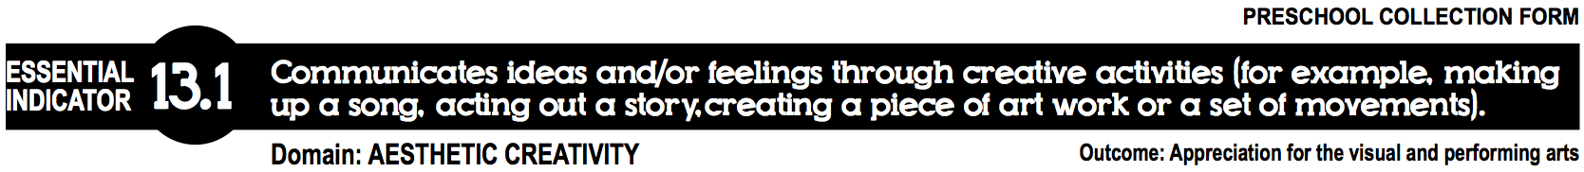

This child’s creative expression has been documented in the following ways:
(Check all that apply, ONE required)
Photo of child’s work (included)
Sample of child’s word (included)
Video of child (included)
Anecdotal note (see description above)
Other:
*See Family Teacher Summary Report form for more information on child’s creative expression

Check the additional Essential Indicators that are embedded in the documentation:
EI # 6.1 (Conversational Ability) | EI #20.1 (Plays and Interacts) | EI #25.3 (Role Plays)
EI #17.4 (Family, Community Culture) | EI #20.2 (Social Problem Solving) | EI #27.1 (Focus)

