Classroom: _____________________________________________ Date __________________

Educator(s): ______________________________________ Interests (optional): ______________________________________________
Beginning to Know Ourselves and Others  Components (Goals):  Play, Explorations, & Routines:  Teaching Strategies, Supports, & Materials: | Beginning to Communicate  Components (Goals):  Play, Explorations, & Routines:  Teaching Strategies, Supports, & Materials: | Beginning to Build Concepts  Components (Goals):  Play, Explorations, & Routines:  Teaching Strategies, Supports, & Materials:
Beginning to Move and Do  Components (Goals):  Play, Explorations, & Routines:  Teaching Strategies, Supports, & Materials: | Approaches toward Learning  Components (Goals):  Play, Explorations, & Routines:  Teaching Strategies, Supports, & Materials: | Additional Experiences  Components (Goals):  Play, Explorations, & Routines:  Teaching Strategies, Supports, & Materials:

Relationship Building and Family Involvement  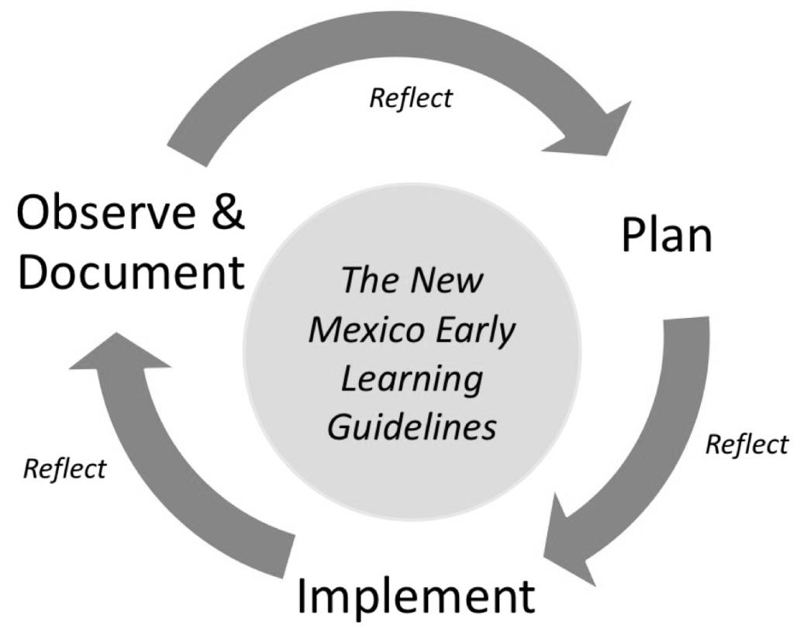 | Modifications for Individual Children
Reflections  What worked? What didn’t? What did you learn about individual children and group interests? | Plans

