Classroom: _____________________________________________ Date ___________________

Educator(s): ____________________________________________ Interests (optional):_________________________________________________
Blocks  Indicators (Goals):  Additional plan:  Teacher support:  Vocabulary Word(s): | Art  Indicators (Goals):  Additional plan:  Teacher support:  Vocabulary Word(s): | Math Center  Indicators (Goals):  Additional plan:  Teacher support:  Vocabulary Word(s):
Dramatic Play  Indicators (Goals):  Additional plan:  Teacher support:  Vocabulary Word(s): | Class Library  Indicators (Goals):  Additional plan:  Teacher support:  Vocabulary Word(s): | Science Center or Sensory Table  Indicators (Goals):  Additional plan:  Teacher support:  Vocabulary Word(s):
Manipulatives  Indicators (Goals):  Additional plan:  Teacher support:  Vocabulary Word(s): | Other Center  Indicators (Goals):  Additional plan:  Teacher support:  Vocabulary Word(s): | Writing Center  Indicators (Goals):  Additional plan:  Teacher support:  Vocabulary Word(s):

 | MONDAY | TUESDAY | WEDNESDAY | THURSDAY | FRIDAY
Large  Group  (as long as children are engaged;  usually 15-20 mins.) | Indicator:  Activity &  Strategy: | Indicator:  Activity &  Strategy: | Indicator:  Activity &  Strategy: | Indicator:  Activity &  Strategy: | Indicator:  Activity &  Strategy:
Small  Group  (if done during play, done as a choice for children) | Indicator:  Activity &  Strategy: | Indicator:  Activity &  Strategy: | Indicator:  Activity &  Strategy: | Indicator:  Activity &  Strategy: | Indicator:  Activity &  Strategy:
Plans for Meals and Transitions  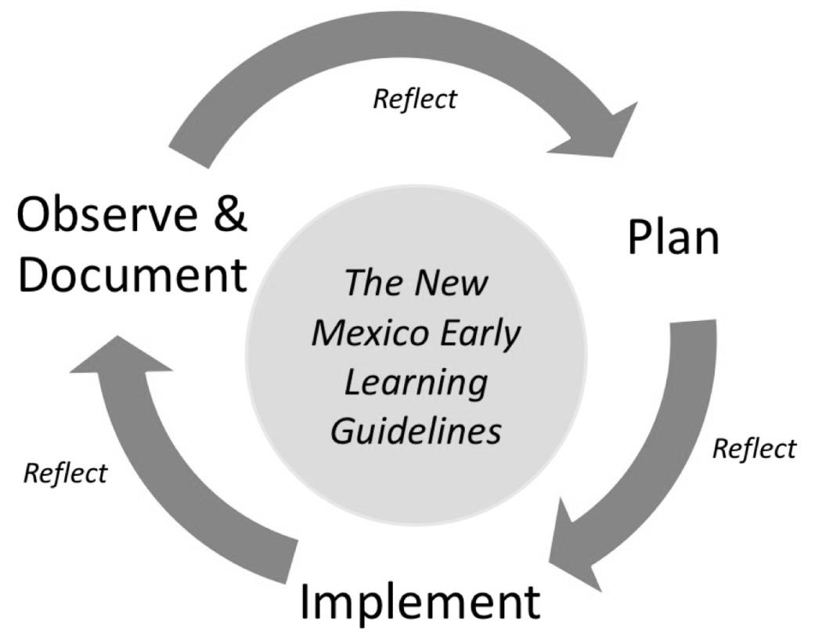 | Outdoor Environment and Explorations |  | Plans for Small Group and/or Individual Reading
Relationship Building and Family Involvement |  | Modifications for Individual Children
Reflections  What worked? What didn’t? What did you learn about individual children and group interests? |  | Plans

